Implement SSH,firewall,automation and SELinux on a server
1.Enable and configure SSH on your Linux server so that only key-based authentication is allowed and password authentication is disabled.
Configure SSH Key-Based Authentication
I generated an SSH key pair and configured key-based authentication by adding the public key to the authorized_keys file.
Commands Used:
ssh-keygen -t ed25519
cat ~/.ssh/id_ed25519.pub >> ~/.ssh/authorized_keys
chmod 700 ~/.ssh
chmod 600 ~/.ssh/authorized_keys
ls -l ~/.ssh
Result:
The SSH key pair was generated successfully. The public key was added to the authorized_keys file, and the correct permissions were applied to the SSH configuration files.
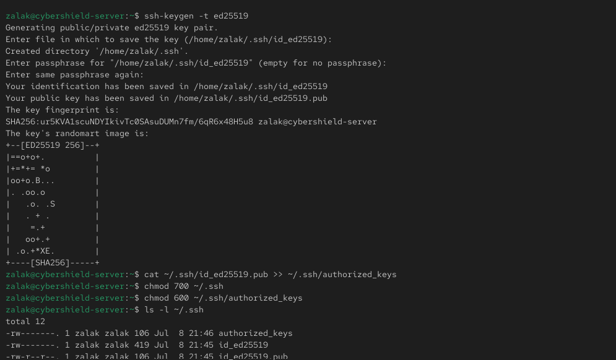
2.Set up a basic firewall using UFW or firewalld to allow only SSH (port 22) and HTTP (port 80) traffic, and block all other incoming connections.<br><br><em><strong>Hint:</strong> After applying rules, use a port scanning tool like nmap from another machine to verify only the allowed ports are open.</em>
Configure the Firewall
I configured the firewall using firewalld to allow SSH (port 22) and HTTP (port 80) services.
Commands Used:
sudo systemctl status firewalld
sudo firewall-cmd --permanent --add-service=ssh
sudo firewall-cmd --permanent --add-service=http
sudo firewall-cmd --reload
sudo firewall-cmd --list-all
Result:
The firewall was configured to allow SSH and HTTP traffic. The active firewall configuration was verified successfully.
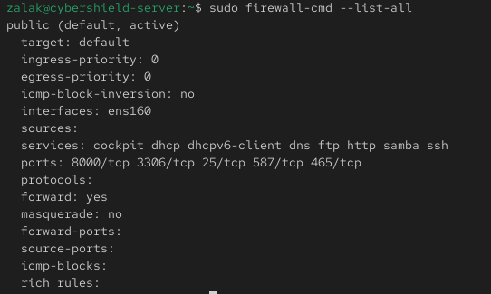
Verify Open Ports Using Nmap
I verified the firewall configuration by scanning the server with Nmap.
Commands Used:
nmap localhost
or
hostname -I
nmap <server_ip_address>
Result:
The scan confirmed that only the required services (SSH on port 22 and HTTP on port 80) were accessible, while other incoming ports were blocked by the firewall.
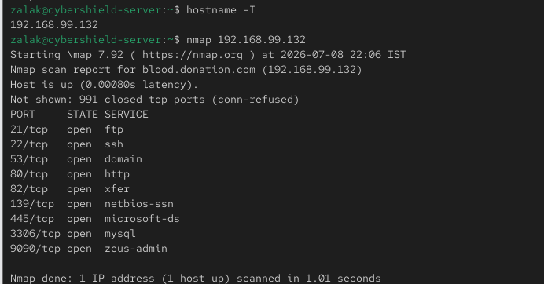

3.Write a shell script automate_backup.sh that creates a backup of your /home directory and saves it with a timestamp in /backups.

Question 3: Create an Automated Backup Script
I created a shell script named automate_backups.sh to create a compressed backup of the /home directory and store it in the /backups directory with a timestamp.
Step 1: Create Backup Directory
Command:
sudo mkdir -p /backups
Step 2: Create Backup Script
Command:
nano ~/automate_backups.sh
Script Content:
#!/bin/bash
DATE=$(date +%F_%H-%M-%S)
tar -czf /backups/home_backup_$DATE.tar.gz /home
Step 3: Make the Script Executable
Command:
chmod +x ~/automate_backups.sh
Step 4: Execute the Backup Script
Command:
sudo ~/automate_backups.sh
Step 5: Verify Backup Creation
Command:
ls -lh /backups
Result:
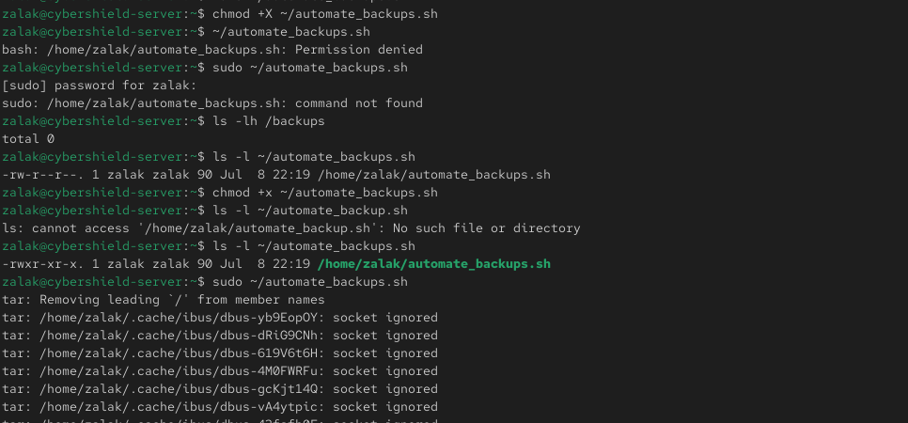
The backup archive was successfully created in the /backups directory with a timestamp-based filename.
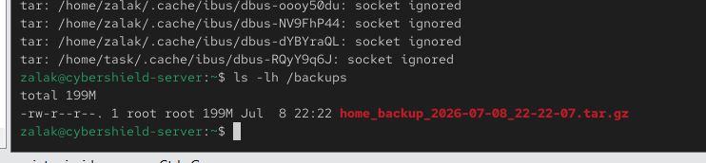

4.Check the current status of SELinux on your server, switch it to enforcing mode if it is not already, and verify the change using appropriate commands.<br><br><em><strong>Hint:</strong> Use the commands getenforce and setenforce.</em>
Question 4: Schedule the Backup Script Using Cron
I scheduled the automate_backups.sh script to run automatically every day at 1:00 AM using the cron scheduler.
Commands Used:
crontab -e
Cron Entry:
0 1 * * * /home/<your_username>/automate_backups.sh
I verified the cron job using:
crontab -l
Result
The cron job was successfully added and verified. It is scheduled to execute the backup script automatically every day at 1:00 AM.
